Executive Summary: Verizon vs. Competitors (AT&T & T-Mobile)
Ravshanbek Mamasaidov

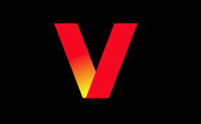

Executive Summary
This report evaluates the financial health and cost of capital of Verizon Communications Inc. using data from its Form 10-K and other reliable sources. Key financial ratios are calculated over the past three years to assess liquidity, solvency, efficiency, profitability, and market performance, and are compared with competitors AT&T Inc. and T-Mobile US, Inc. to determine Verizon’s relative position in the telecommunications industry. Based on this analysis, the report provides an overall assessment of the company’s financial condition, highlighting major trends, strengths, and weaknesses. In addition, the cost of equity is estimated using both CAPM and the Dividend Discount Model (DDM), while the cost of debt is derived from bond yield data; these are then combined to calculate the firm’s weighted average cost of capital (WACC). All calculations are performed in Excel and are clearly organized to support the findings and conclusions.
Verizon’s Past 3-Yr Financial Ratio Analysis
We have conducted financial ratio analysis to capture a comprehensive view of Verizon’s operational performance and financial stability by examining its liquidity, solvency, efficiency, and profitability over time. By evaluating these metrics based on the past three years performances, as shown in Exhibit 1, our intent is to present our client with key trends and underlying financial conditions within the firm.
From a liquidity perspective, Verizon has historically operated below the conventional benchmark of 1.0, with current and quick ratios declining through 2024 before improving to 0.9127 and 0.8735, respectively, in 2025 from 0.69 in 2023. The cash ratio also increased significantly to 0.3054 in 2025 from minimal levels in prior years. While these levels suggest limited short-term flexibility in isolation, they are consistent with the characteristics of a subscription-based, service-oriented business model that generates stable and predictable cash flows. The recent upward trend indicates strengthening short-term financial positioning.
Followed by long-term solvency. In terms of solvency, Verizon maintains a highly leveraged capital structure, with a debt-to-equity ratio of 2.82 and a debt-to-assets ratio of 0.74. Despite this, the company demonstrates adequate debt servicing capability, supported by an interest coverage ratio of 4.37. This suggests that while leverage remains elevated, it is manageable given the firm’s consistent earnings and strong cash flow generation.
Operationally, Verizon exhibits strong efficiency, particularly in accounts receivable turnover, reflecting effective collection of revenues from its customer base. Total asset turnover remains moderate, which is expected given the capital-intensive nature of the telecommunications industry. Inventory turnover is also aligned with a service-focused model where physical inventory plays a less significant role. Furthermore, profitability remains stable, with a net profit margin of 12.43%, a return on assets of 4.25%, and a return on equity of 16.24%. These metrics indicate consistent returns generated from both assets and shareholder investments.
In summary, Verizon’s financial ratios reflect an operationally efficient and financially stable position, with improving liquidity and manageable leverage supported by predictable and recurring cash flows.
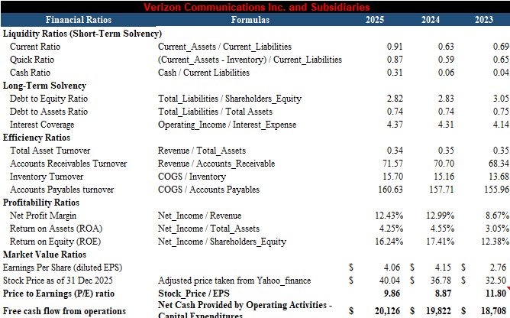
Exhibit 1:Verizon’s Financial Ratio (2023-2025) Trend
Position Against Its Competitors
Benchmarking Verizon against key competitors provides context for evaluating its relative performance within the telecommunications industry. Exhibit 2 presents a comparison of Verizon, AT&T, and T-Mobile across key financial, operational, and market metrics, allowing for a clear assessment of relative strengths and weaknesses.
From a liquidity perspective, Verizon remains comparable to AT&T but trails T-Mobile, with a current ratio of 0.91 versus T-Mobile’s 0.998, and a quick ratio of 0.87 compared to 0.90. Verizon’s cash ratio of 0.31 exceeds T-Mobile’s 0.23 but remains slightly below AT&T’s 0.34, indicating moderate short-term liquidity relative to peers. In terms of leverage, Verizon carries a higher debt burden, with a debt-to-equity ratio of 2.82, compared to AT&T (2.32) and T-Mobile (2.70). However, it maintains stronger interest coverage than AT&T (4.37 vs. 3.55), though slightly below T-Mobile (4.84), suggesting that its higher leverage remains manageable.
Operationally, Verizon demonstrates strong efficiency, particularly in accounts receivable turnover (71.57), significantly exceeding AT&T (25.69) and T-Mobile (20.15), reflecting effective revenue collection. Its total asset turnover (0.34) remains moderate, above AT&T (0.30) but below T-Mobile (0.40), consistent with the capital-intensive nature of the industry. Profitability is stable but not leading, with a net profit margin of 12.43%, below AT&T (17.42%) and slightly below T-Mobile (12.45%), and return on equity of 16.24%, trailing both competitors. From a market valuation perspective, Verizon’s price-to-earnings ratio of 9.86 reflects a more mature, lower-growth profile compared to T-Mobile (20.79), while remaining slightly above AT&T (8.08).
Notably, Verizon generates the highest free cash flow from operations at $20,126, exceeding AT&T ($19,442) and T-Mobile ($17,995), reinforcing its position as a strong cash flow-driven firm. Overall, Verizon is positioned as a stable incumbent, characterized by strong operational efficiency and cash flow generation, balanced against higher leverage and more moderate growth expectations relative to its competitors.
Overall, Verizon is positioned as a stable incumbent within the industry, balancing operational efficiency and strong cash flow generation with higher leverage and more modest growth expectations relative to its competitors.
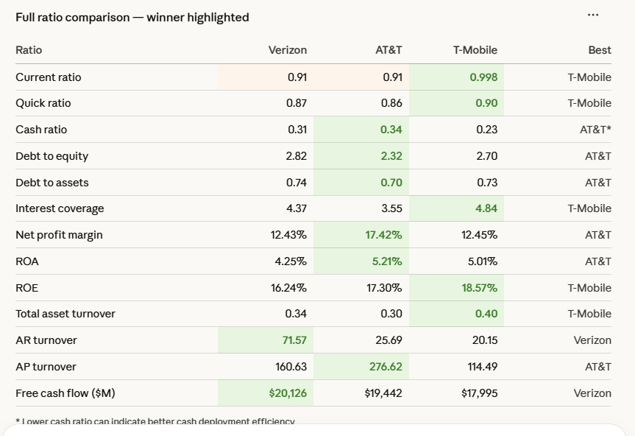
Exhibit 2: Verizon vs AT&T & T-Mobile (Financial Ratio Comparaison Table)
Verizon’s Overall Financial Health Standing
Understanding Verizon’s cost of capital provides insight into how efficiently the company finances its operations and investments. By analyzing the cost of equity, cost of debt, and weighted average cost of capital (WACC), we can assess our client’s overall financing costs and its ability to generate returns that exceed these required thresholds.
Cost of Equity
The cost of equity represents the return required by shareholders for investing in Verizon and is estimated to be using both the Capital Asset Pricing Model (CAPM) and the Dividend Discount Model (DDM). The CAPM approach yields an estimated cost of equity of 6.68%, while the DDM approach results in 3.73%, leading to a blended estimate of approximately 5.20%.
The CAPM estimate incorporates a beta of 0.30, indicating low systematic risk and defensive stock characteristics. This suggests that investors view Verizon as a stable, income-oriented investment with limited sensitivity to market fluctuations. The lower DDM estimate reflects modest dividend growth expectations, consistent with the company’s mature business profile.
Overall, Verizon’s cost of equity indicates strong investor confidence in its stability, though it also reflects limited growth expectations relative to higher-growth competitors.
Cost of Debt
The cost of debt reflects the effective interest rate our client pays on its borrowings and is adjusted for the tax benefits associated with interest expense. Verizon’s pre-tax cost of debt is estimated at 4.52%, which decreases to 3.57% after accounting for tax effects.
This relatively low cost of debt indicates that Verizon maintains strong access to capital markets and benefits from favorable borrowing conditions. The ability to finance operations at a relatively low cost supports its long-term investment strategy.
However, the firm’s substantial reliance on debt exposes it to interest rate fluctuations and refinancing risk. As a result, maintaining a balance between leveraging low-cost debt and preserving financial flexibility remains critical.
Weighted Average Cost of Capital
The weighted average cost of capital (WACC) represents Verizon’s overall cost of financing by combining both equity and debt based on their respective proportions in the firm’s capital structure, serving as a key benchmark for evaluating investment performance. As shown in Exhibit 6, Verizon’s WACC is estimated at approximately 4.46%, supported by a capital structure of 54.35% equity and 45.65% debt, with a cost of equity of 5.20% and an after-tax cost of debt of 3.57%. Exhibit 6 summarizes these components and illustrates how each contributes to the firm’s overall cost of capital.
The relatively low WACC indicates that Verizon benefits from inexpensive financing, enabling the company to pursue capital-intensive investments with lower required returns. However, this advantage is closely tied to its reliance on debt financing, which introduces exposure to interest rate and refinancing risk. Overall, Verizon’s WACC reflects an efficient financing strategy, but maintaining this advantage will depend on disciplined capital structure management and sustained cash flow generation.
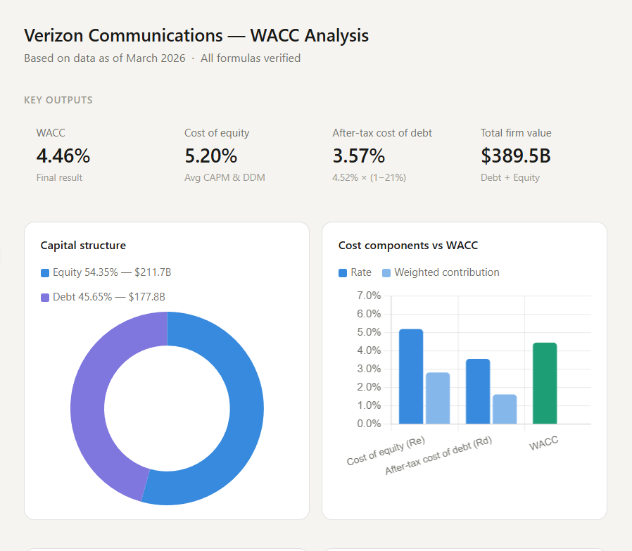
Exhibit 3: Verizon’s WACC Analysis
Recommendation
Verizon clearly demonstrates a financially stable and operationally efficient business model supported by strong cash flow generation and predictable revenue streams. Its relatively low cost of capital enhances its ability to fund long-term investments and sustain shareholder returns. However, when viewed strictly from a financial performance perspective, our client does not consistently lead its peer group. While it excels in operational efficiency and cash flow generation, it trails competitors in key areas such as profitability and carries a higher level of financial leverage.
This positioning suggests that Verizon currently operates as a stable, cash flow-driven incumbent rather than a growth leader, with its competitive advantage rooted in reliability rather than superior financial performance across all metrics. To strengthen its position relative to AT&T and T-Mobile, Verizon should focus on strategically leveraging its strong cash flows and low cost of capital to invest in growth-oriented initiatives, such as network expansion, service innovation, and customer value enhancements. At the same time, the company should maintain disciplined capital structure management by gradually reducing reliance on debt to improve financial flexibility.
By balancing its core strength in stability with targeted efforts to enhance growth and profitability, Verizon can transition from a defensive, income-oriented profile toward a more well-rounded competitor that combines financial strength with sustainable competitive advantage.

References
- AT&T Inc. (2026). Form 10-K for the fiscal year ended December 31, 2025. U.S. Securities and Exchange Commission.
- T-Mobile US, Inc. (2026). Form 10-K for the fiscal year ended December 31, 2025. U.S. Securities and Exchange Commission.
- Verizon Communications Inc. (2024). Form 10-K for the fiscal year ended December 31, 2023. U.S. Securities and Exchange Commission.
- Verizon Communications Inc. (2025). Form 10-K for the fiscal year ended December 31, 2024. U.S. Securities and Exchange Commission.
- Verizon Communications Inc. (2026). Form 10-K for the fiscal year ended December 31, 2025. U.S. Securities and Exchange Commission.
- Duanmu, J. (n.d.). Risk, cost of capital and valuation: Solutions [Course material]. Seattle University Canvas. https://seattleu.instructure.com/courses/1630642/files/73271519?module_item_id=18792593.
- Yahoo Finance. (n.d.). Verizon Communications Inc. (VZ) key statistics. https://finance.yahoo.com/quote/VZ/key-statistics/.
- The Wall Street Journal. (n.d.). Verizon Communications Inc. (VZ). https://www.wsj.com/market-data/quotes/VZ.

